Vijay Sarathy BIA 658 Final Project

The effect of Social Network on a Recently Released Movie’s Sales

**About Ted 2 and Motivation**

Social Network Analysis can be applied to the prediction of product consumption which is an integral asset of any business. The project focused on the motion picture industry, particularly summer blockbusters.

Ted 2 is a comedy sequel to Ted, which broke box office records at $550 million upon its release. Based on previous research linking social network activity to movie sales [1][2][3], this project will entail tracking the volume of tweets three days before release as well as three days after. Also, the feedback from boxoffice mojo will be monitored to verify box office sales.

**Methods**

Basic social network visualization was accomplished using NodeXL to extract Twitter followers data and then Gephi to visualize the obtained network further.

Tracking of daily tweets in regards to the movie was performed using the TwitterR R package. The word cloud and user location map was also performed by R. The functions are attached in movie_vijay.R, word_cloud.R. The map was generated using the lines: source(“http://biostat.jhsph.edu/~jleek/code/twitterMap.R”)  
> twitterMap("WhatTedSaid", fileName=”WhatTedSaid.pdf”, nMax=1500)

**Results**

*Twitter Network*

Ted 2 has a large Twitter community with the following websites: <https://twitter.com/ted2official>, <https://twitter.com/SethMacFarlane>, <https://twitter.com/mark_wahlberg>, <https://twitter.com/_jessicabarth_>, <https://twitter.com/WhatTedSaid>, <https://twitter.com/LegalizeTed> . Each of the six websites has a roughly equal following (Figure 1).

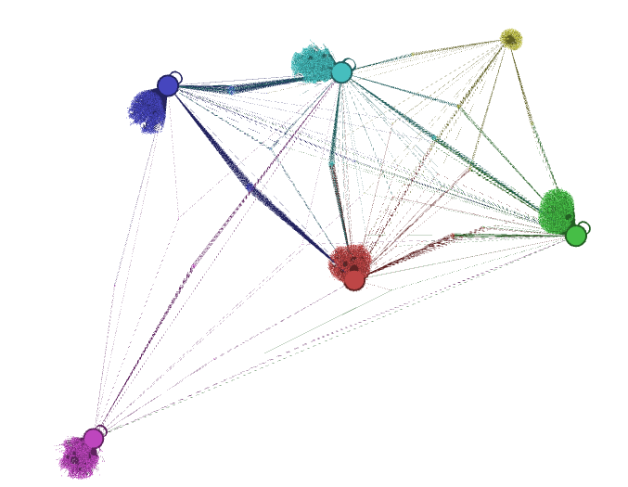

Figure 1: The Twitter pages and their followers. There is a total of approximately 10,000 nodes as well as a large and roughly even distribution of followers and edges between the six pages/ hubs.

*Word Cloud*

The word cloud (Figure 2) content suggests that there are several fan planning to see the film.

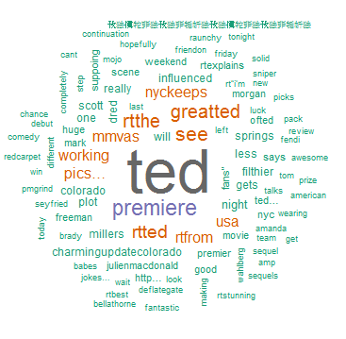

Figure 2: Word cloud of tweets from a sample of 500 tweets and a word count of 100. “See” and “premiere” are prevalent.

*Map of followers*

One of the advantages of using a social network is that it can reach a large geographic range (Figure 3). Therefore, there should be viewership and box office numbers internationally.

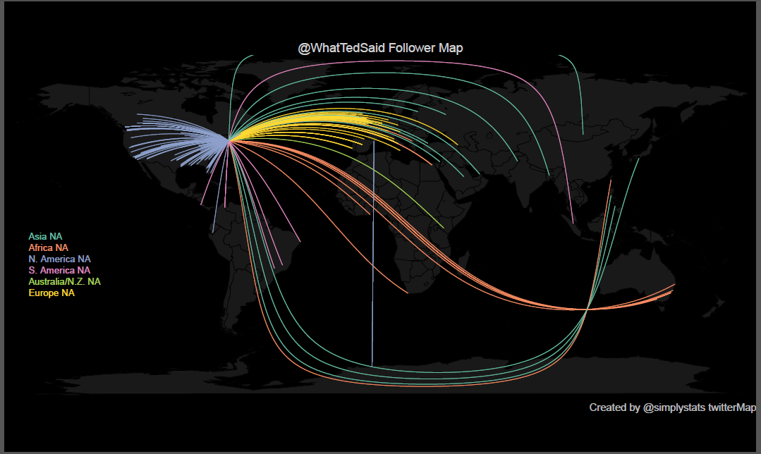

Figure 3: Follower map for WhatTedSaid twitter page. Although there is a wordwide following, there is a large aggregation of US and European followers.

*Tweet Count*

Daily tweet counts were captured by movie_vijay.R using the searchTwitter function (Figure 4) for the hashtag ‘#ted2’. In the six days covered, there was a total of approximately 25,000 tweets.

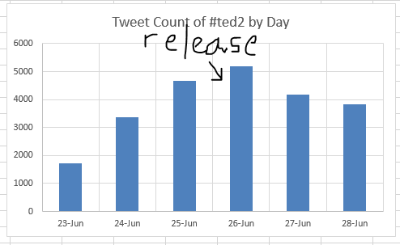

Figure 4: Count of tweets mentioning #ted: there is a steady increase in the days preceding the release of Ted2 and a slow decline after.

The weekend gross (Jun 26-28) was $53.3million, as reported by boxofficemojo.com. Its ranking was #3 in the box office.

**Discussion**

The data obtained is a sample of tweets due to the API restriction. However, the sample is quite large and shows that there was indeed an active twitter campaign for the movie. This suggests that the twitter buzz may have been a contributing factor to the movie’s box office success.

**References**

[1] McAuley, Julian and Jure Leskovec. *From Amateurs to Connoisseurs: Modeling the Evolution of User Expertise through Online Reviews* (2013). May 13–17, 2013, Rio de Janeiro, Brazil: ACM 978-1-4503-2035-1/13/05.

[2] Asur, Sitaram and Bernardo A. Huberman. *Predicting the Future With Social Media.* arXiv:1003.5699v1 [cs.CY] 29 Mar 2010

[3] Rui, Huaxia, Yizao Liu, and Andrew Whinston. *Whose and what chatter matters? The effect of tweets on movie sales Decision Support Systems.* 55 (2013): 863–870.